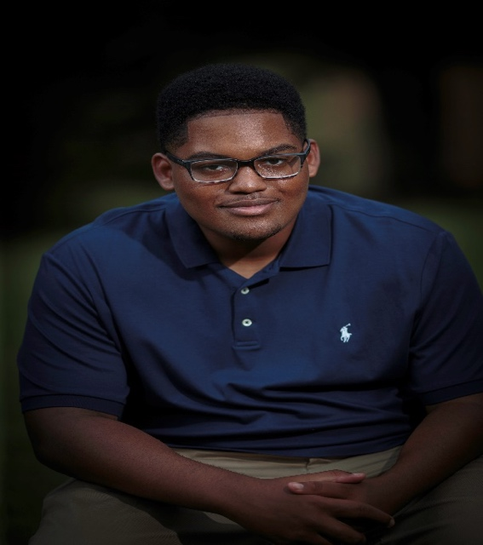

Landon Douglas Hughes
President, Esquires - Progressive Art and Civic Club

COMMUNITY AWARDS/ACCOMPLISHMENTS -
*Esquire leadership award for 2020
*Vice President of MSFCWC at the Federated State level
*State art winner for 2019-2020
*2nd Place scrapbook winner - 2020
*2nd Place in the Frederick Douglas South Eastern Regional Frederick Douglas Essay 2021
*Voted by staff summer 2020 Camper of the Year at Delta State University Art camp;
*Worked the voting precincts November 2021 distributing water and snacks to voters who were waiting in line
*Member of Greenville Mayors Youth Council for the past 4 years
*Invited and hosted Miss Mississippi Aysa Branch to come to Greenville and speak to the Federated Youth Group and the youth of the city

ST JOSEPH HIGH SCHOOL -
*Member - National Honor Society - 2021 Vice President
*Member of the Fighting Irish Football Team
*Drama Club and Best actor 2021
*2nd Place State Art winner - 2020 -2021
*Saint of the Week - 2021
*Senior Class Representative 2021
*Local, Regional and State Science Fair Winner 2020

MERCY SEAT MISSIONARY BAPTIST CHURCH - YOUTH MINISTRY
*Youth Choir, Junior Deacon and Prayer leader
*Youth Sunday School Superintendent

